NASA Railroad

**From Wikipedia, the free encyclopedia**

https://en.wikipedia.org/wiki/NASA%20Railroad  
Licensed under CC BY-SA 3.0:  
https://en.wikipedia.org/wiki/Wikipedia:Text_of_Creative_Commons_Attribution-ShareAlike_3.0_Unported_License

# NASA Railroad

* *The railroad consists of 38 miles (61 km) of track connecting the mainline of the Florida East Coast Railway and trackage at the Cape Canaveral Air Force Station.*
* *The NASA Railroad (reporting mark NLAX) is a Class III industrial short-line railroad at the Kennedy Space Center in Cape Canaveral, Florida.*

The NASA Railroad (reporting mark NLAX) is a Class III industrial short-line railroad at the Kennedy Space Center in Cape Canaveral, Florida. The railroad consists of 38 miles (61 km) of track connecting the mainline of the Florida East Coast Railway and trackage at the Cape Canaveral Air Force Station.

# Overview

* *In the spring of 2015, it was announced that the NASA railroad would formally cease operations.*
* *In 2014, NASA donated locomotive #2 to the Gold Coast Railroad Museum in Miami where it remains on static display.*
* *NASA used the railroad to transport equipment which could not be transported over the road to and from other NASA locations.*

NASA used the railroad to transport equipment which could not be transported over the road to and from other NASA locations. Rail transportation also offered cost savings over transporting bulky and heavy cargo via barge or aircraft. Much of the rail traffic was devoted to sending segments of the reusable solid rocket boosters (SRB) from the Thiokol plant in Utah back again for refurbishment after Space Shuttle launches and recovery. A total of 24 cars were devoted to transporting the SRBs.

With the end of the Shuttle program in 2011, the railroad's future became uncertain and went under review by the government. One possibility that was being considered was the delivery of equipment for private space launches at Cape Canaveral. In 2012, the program's helium tank cars, a liquid oxygen tank car, and a liquid hydrogen tank car were transferred for delivery to the SpaceX engine test complex outside McGregor, Texas, where they were re-purposed to support their engine tests. Originally, the tank cars belonged to the U.S. Bureau of Mines. Eight other cars were shipped to California and are currently on lease to SpaceX to support Falcon 9 rocket launches from Space Launch Complex-4 at Vandenberg Air Force Base. SpaceX already uses three helium tank cars at Space Launch Complex-40 on Cape Canaveral Air Force Station in Florida, which were previously used for the shuttle program.

In 2014, NASA donated locomotive #2 to the Gold Coast Railroad Museum in Miami where it remains on static display. In the spring of 2015, it was announced that the NASA railroad would formally cease operations. The remaining two locomotives, #1 & #3, were pulled from service and delivered via the Florida East Coast Railway to their respective new homes. Locomotive #1 was sold to the Natchitoches Parish Port in Natchitoches, Louisiana, while locomotive #3 was sold to the Madison Railroad in Madison, Indiana, where it is used for regular freight service and passenger excursion train service. As of 2016, much of the trackage along the East Leg as well as in the KSC Industrial Area had been pulled up and was presumably scrapped, although the majority of trackage along the West Leg still remains abandoned in place.

Currently, NASA is considering plans to possibly resurrect the railroad in 2019/2020 when the new deep space Space Launch System (SLS) program becomes operational. The railroad would once again transport segments of the two shuttle-derived solid fuel rocket boosters that will be used on the initial flights of the SLS. Each booster will provide 3.6 million pounds of thrust by adding one additional solid fuel propellant segment to the modified shuttle boosters (5 sections for the SLS vs. 4 for the STS). This SLS booster will be the largest, most powerful solid propellant boosters ever built. The boosters will once again be manufactured by Orbital ATK in Utah and shipped cross country by rail.

# Equipment

* *The NASA Railroad operates three SW1500 switcher locomotives, each former Toledo, Peoria and Western Railway units and 75 rolling stock cars.*
* *The fleet is maintained by the NASA Railroad shop, which also maintains locomotives and cars for the Cape Canaveral Air Force Station.*

The NASA Railroad operates three SW1500 switcher locomotives, each former Toledo, Peoria and Western Railway units and 75 rolling stock cars. The fleet is maintained by the NASA Railroad shop, which also maintains locomotives and cars for the Cape Canaveral Air Force Station.

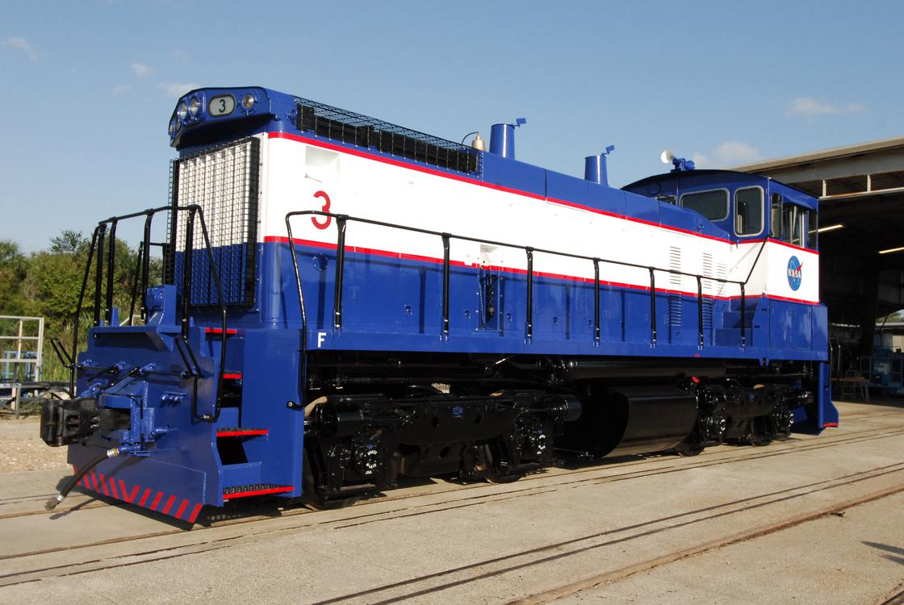  
*Locomotive #3 outside of the maintenance shops at KSC*

# Locomotives

# Rolling stock

# See also

* *List of United States railroads  
  List of Florida railroads*

List of United States railroads  
List of Florida railroads

# References

# External links

* *Rockets and Rails: The NASA Railroad at YouTube.com*

Rockets and Rails: The NASA Railroad at YouTube.com